Week 3 Lab: AWS CLI Syntax, Launching EC2 Instances, and Environment-Based Scripting
Check point 1:
Screenshot of a decomposed aws ec2 describe-instances command with each part labeled (service/operation/parameters).
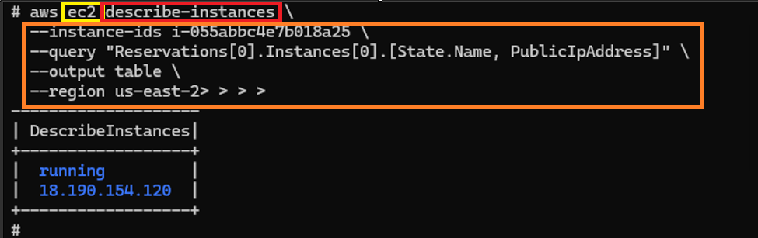
Service:
- Ec2
Operation:
- Describe-instances
Parameters:
- --instance-ID
- --query
- --output table
- --region

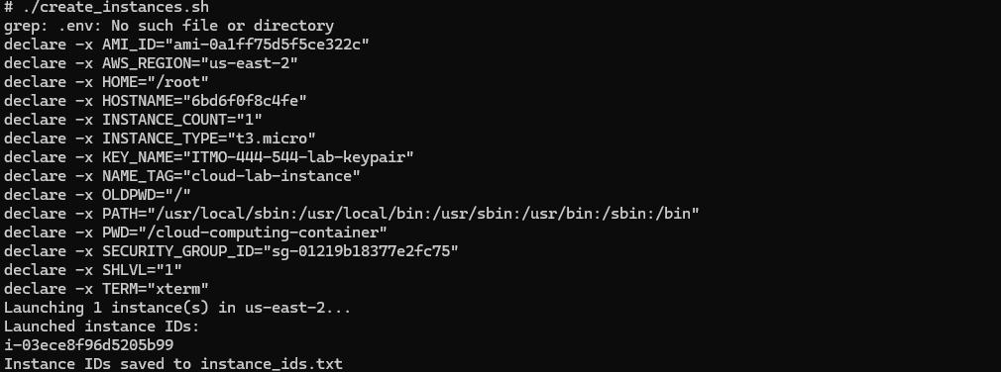
Check point 2: Screenshot of the “Hello from…” web page:
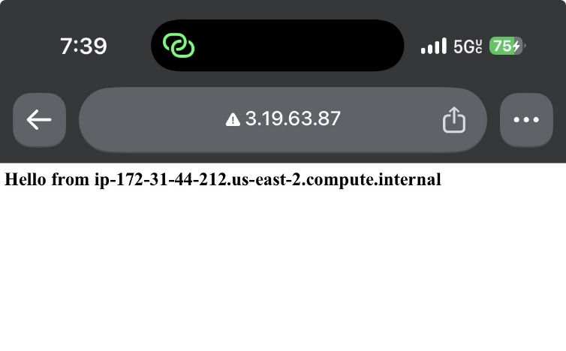
Check point 3: Screenshot of git status showing .env is not tracked, alongside your .gitignore file contents.
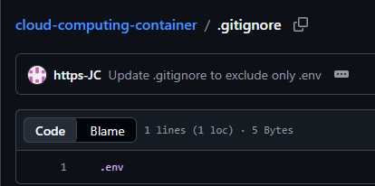
Check point 4: Screenshot of create_instances.sh output showing 2 instance IDs.
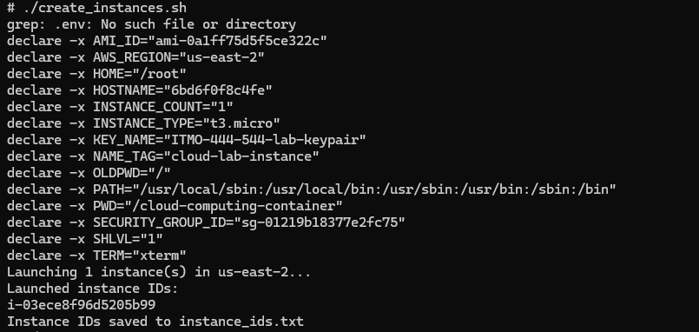
Checkpoint 5: Screenshot of delete_instances.sh output confirming termination.
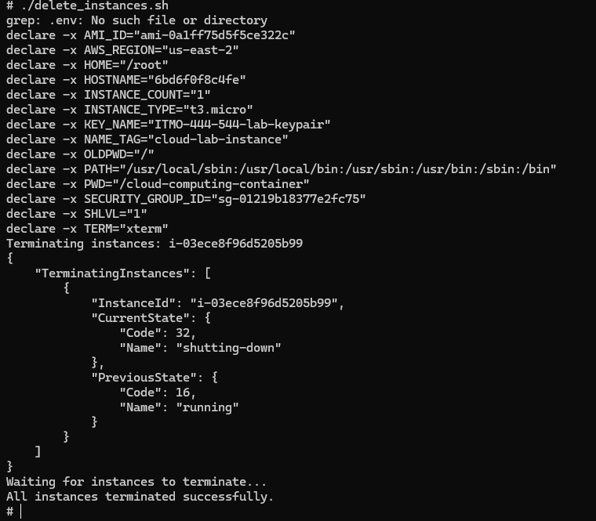
Checkpoint 6:
Link to your GitHub repo:
https://github.com/https-JC/cloud-computing-container/tree/main
One paragraph explaining why environment files are excluded from Git, even in a “private” repository.
Making sure env files are excluded from git is important for security. The .env file includes sensitive information containing security keys or sensitive id’s. Excluding this will prevent exposure by accident.

